**R and Python code for data visualization**

1. Pie chart in Python (Figure 2A)

2. Area plot in Python (Figure 2B)

3. Heatmap with numbers in R (Figure 2E)

4. Stacked bar plot in R (Figure 3A)

5. One-layer circular tree plot in R (Figure 4A)

6. Network plot with layout in circle in R (eFigure 4A)

7. Heatmap for inclusion criteria in R (Figure 5)

8. Hierarchical Pie Chart in Python (Figure 6A)

9. Heatmap for composite endpoint breakdown in R (Figure 7A)

10. Lasagna plot in R (eFigure 2A)

1. Pie chart in Python (Figure 2A)

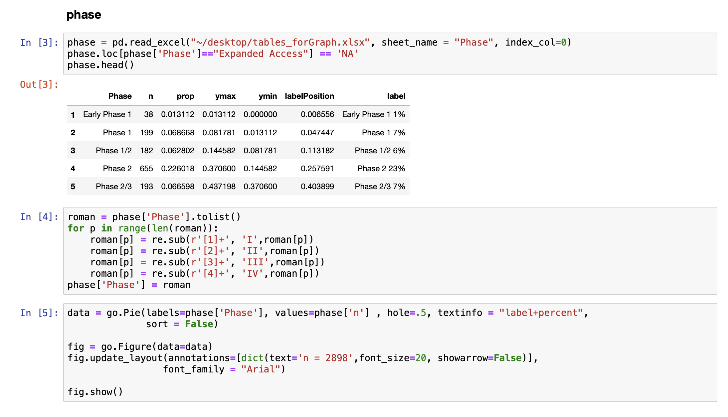



2. Area plot in Python (Figure 2B)

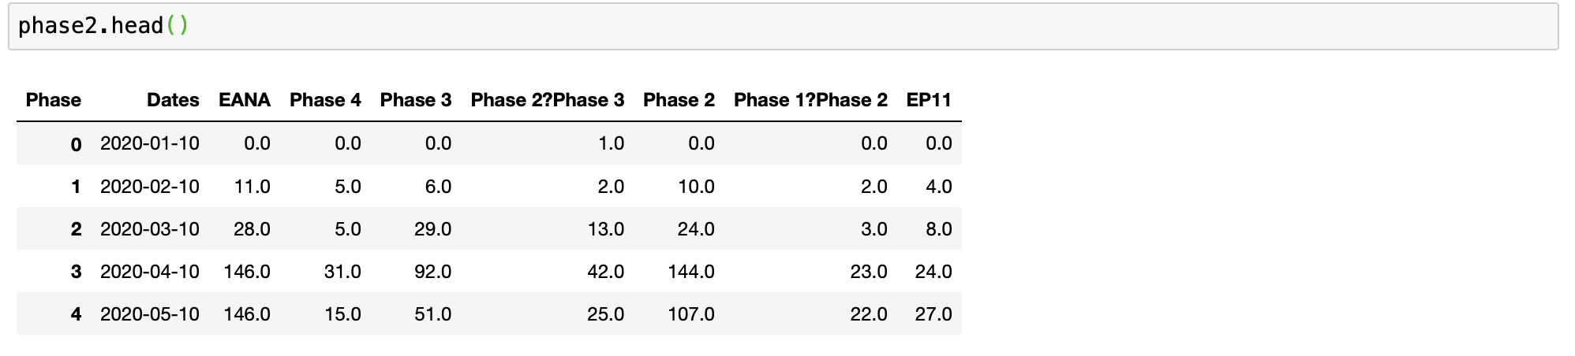

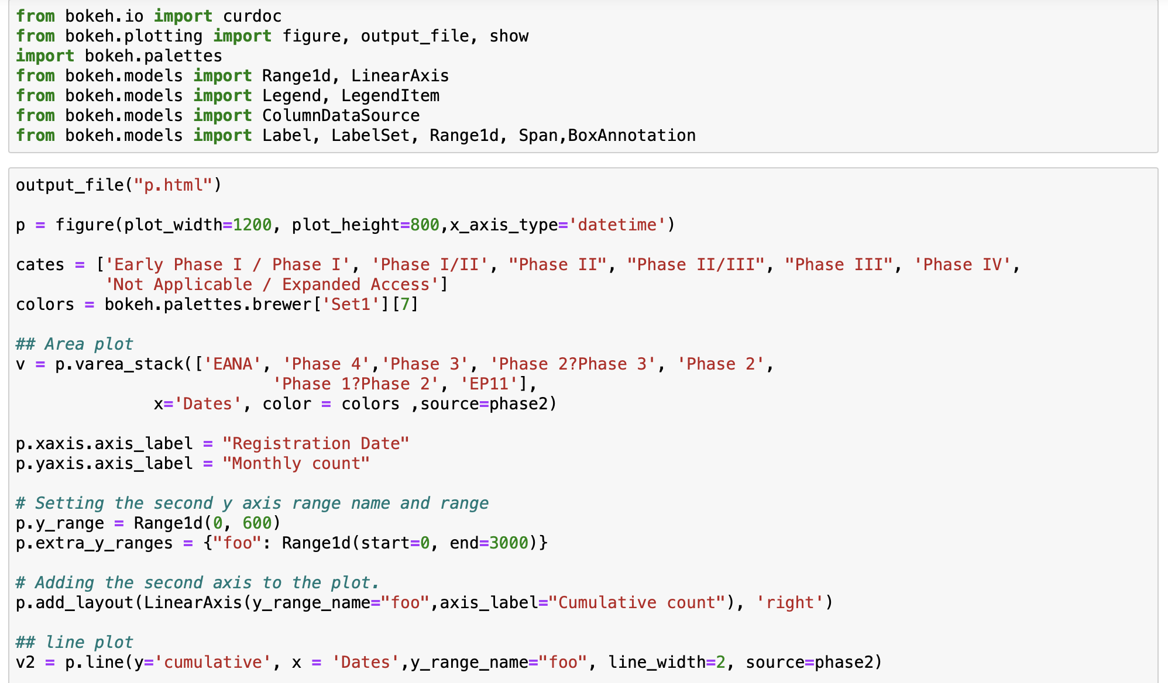

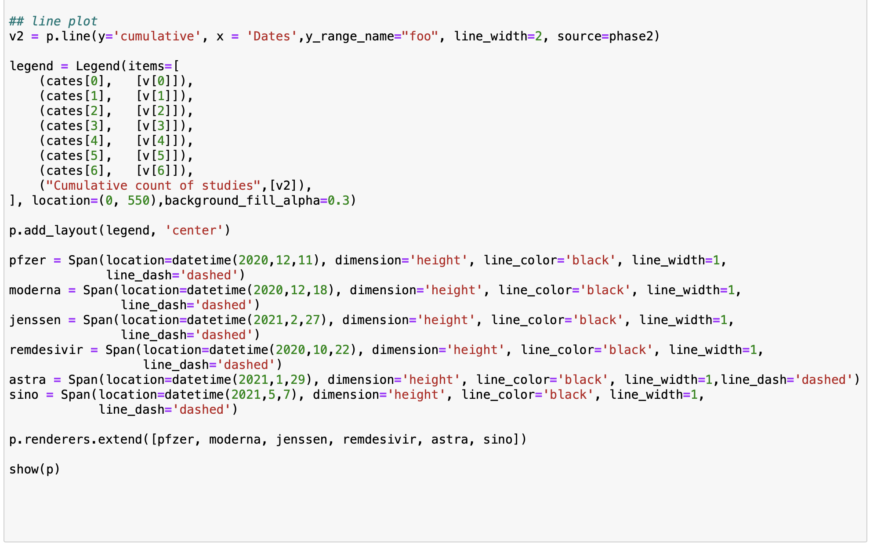

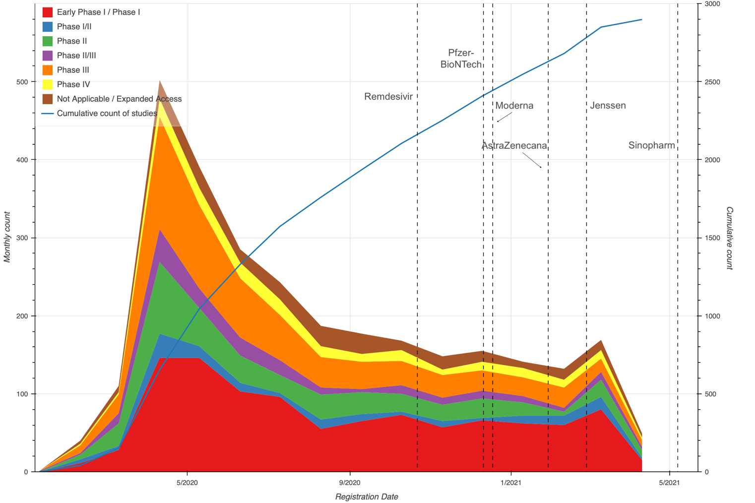

3. Heatmap with numbers in R (Figure 2E)

head(hpds)

## # A tibble: 6 x 4  
## # Groups: Phase [2]  
## Phase DesignPrimaryPurpose SampleSize n  
## <fct> <fct> <dbl> <int>  
## 1 Early Phase 1 "Other\n(n=587)" 60 7  
## 2 Early Phase 1 "Prevention\n(n=479)" NA 3  
## 3 Early Phase 1 "Treatment\n(n=1832)" 33 28  
## 4 Phase 1 "Other\n(n=587)" 30 15  
## 5 Phase 1 "Prevention\n(n=479)" 90 56  
## 6 Phase 1 "Treatment\n(n=1832)" 32 128  
  
heatmap <- ggplot(hpds, mapping = aes(x = Phase, y = DesignPrimaryPurpose, fill = SampleSize)) +  
 geom_tile(color = "black") +  
 geom_text(aes(label = SampleSize)) +  
 scale_fill_gradient(name = "Median Sample Size",  
 low = "#ffe7b3",  
 high = "#ed3a2d",  
 na.value = "#faf2e1") +  
 theme_bw() +  
 theme(axis.title.y = element_blank(), axis.title.x = element_blank(), axis.text.x = element_text(angle = 45, hjust = 1) ) +  
 scale_y_discrete(limits = rev(levels(as.factor(hpds$DesignPrimaryPurpose)))) + coord_equal()



4. Stacked bar plot in R (Figure 3A)

head(SD.data)

## Strata Var1 Freq Tot levels Perc Perct Total  
## 1 Total Adaptive 72 621 1 11.6 11.6% N = 621  
## 2 Total Crossover 9 621 1 1.4 N = 621  
## 3 Total Factorial 11 621 1 1.8 N = 621  
## 4 Total Parallel 491 621 1 79.1 79.1% N = 621  
## 5 Total Platform 2 621 1 0.3 N = 621  
## 6 Total Sequential 14 621 1 2.3 N = 621

SD.fig <- ggplot(SD.data, aes(fill=Var1, y=Perc/100, x=reorder(Strata, +levels))) +   
 geom_bar(stat="identity") +   
 scale_y_continuous(labels = scales::percent) +   
 geom_text(aes(label = Perct), position = position_stack(vjust = 0.5), size = 3) +  
 geom_text(data = total, aes(x = Strata, y = 1, label = tot, fill = NULL), position = position_stack(vjust = 1.02)) +   
 theme_bw() +  
 scale_fill_nejm()+   
 theme(axis.title.x = element_blank(), axis.text.x = element_text(angle = 45, hjust=1), axis.title.y = element_blank(), legend.title = element_blank())  
SD.fig



5. One-layer circular tree plot in R (Figure 4A)

This was inspired by Torsten Sprenger’s work (<https://github.com/spren9er>) and we modified his R code available at <https://github.com/spren9er/tidytuesday/blob/master/tidytuesday_201946_cran_packages.r>.

head(TrtLong)

## # A tibble: 6 x 4  
## Trt num main Class   
## <chr> <dbl> <dbl> <chr>   
## 1 25-Hydroxyvitamin D3 1 1 Antiinflammatory  
## 2 Abatacept 1 1 Antiinflammatory  
## 3 ABX464 1 1 Antiinflammatory  
## 4 Acacia Senegal 1 1 Antiinflammatory  
## 5 Acalabrutinib 1 1 Antiinflammatory  
## 6 ACEIs 1 1 Antiviral/RAS

# Assign colors  
trtclass_colors <- c(brewer.pal(n=8,name = "Set2"), "#A6CEE3")   
names(trtclass_colors)<-c(unique(TrtLong$Class),"All")  
  
# Edges and vertices  
edges1 <- TrtLong %>%  
 transmute(from = Class, to = Trt, num=num, main)  
  
edges2 <- TrtLong %>%  
 dplyr::count(Class, wt = num, name = 'num') %>%  
 transmute(  
 from = '',  
 to = Class,  
 num,  
 main = TRUE  
 )  
  
edges <- bind_rows(edges1, edges2)  
  
vertices1 <- TrtLong %>%  
 filter(main==1) %>%  
 transmute(  
 Trt = Trt, Class, num, level = 1  
 )  
  
vertices2 <- edges2 %>%  
 transmute(  
 Trt = to, Class = to, num, level = 2  
 )  
  
vertices3 <- tibble(  
 Trt = '', Class = NA, num = 0, level = 3  
)  
  
vertices <- bind_rows(vertices1, vertices2, vertices3) %>%  
 mutate(  
 radius = num**(1.8), # scaling circles  
 Class = factor(Class, names(trtclass_colors))  
 ) %>% arrange(level, Class, Trt)  
  
graph <- graph_from_data_frame(edges, vertices = vertices)  
  
# Create custom layout by updating existing circle layout  
layout <- create_layout(graph, layout = 'circle')  
  
# Set outer circle  
n <- nrow(TrtLong)  
outer_circle <- layout %>%  
 filter(level == 1) %>%  
 mutate(Class = factor(Class, names(trtclass_colors))) %>%  
 arrange(Class, desc(name)) %>%  
 mutate(  
 x = cos((row_number() - 1) / n * 2.007 * pi),  
 y = sin((row_number() - 1) / n * 2.007 * pi)  
 )  
  
# Positioning circle centers manually by specifying polar coords

angles <- c(40, 120, 180, 230, 260, 310, 345, 363, 0)

radii <- c(0.5, 0.4, 0.5, 0.4, 0.5, 0.2, 0.65, 0.65, 0.5)  
  
centers <- tibble(  
 x = radii * cos(angles / 180 * pi),  
 y = radii * sin(angles / 180 * pi)  
)  
inner_circle <- bind_cols(centers, select(filter(layout, level != 1), -x, -y))  
  
layout[] <- bind_rows(outer_circle, inner_circle) %>% arrange(.ggraph.index)  
  
# Plot figure  
TrtClass <- ggplot(layout) +   
 geom_edge_diagonal(  
 aes(edge_color = node1.Class, edge_alpha = as.factor(main),),  
 edge_width = 0.4, show.legend = F  
 ) +  
 xlim(-1.6, 1.6) + ylim(-1.4, 1.55) +  
 geom_node_point(  
 aes(size = radius, color = Class),  
 alpha = 0.6, show.legend = FALSE  
 ) +  
 geom_node_text(  
 aes(  
 x = 1.0175 * x,  
 y = 1.0175 * y,  
 label = name,  
 angle = -((-node_angle(x, y) + 90) %% 180) + 90,  
 filter = !(name %in% TrtLong$Class)  
 ),  
 size = 1.8, hjust = 'outward', family = 'Arial'  
 ) +  
 geom_node_text(  
 aes(  
 x = x,  
 y = y,  
 label = name,  
 filter = name %in% TrtLong$Class  
 ),  
 size = 3, hjust = 0.5, family = 'Arial', fontface = "bold"  
 ) +  
 geom_node_text(  
 aes(  
 x = x,  
 y = y - 0.045,  
 label = ifelse(  
 num > 100,  
 format(num, big.mark = ','),  
 num  
 ),  
 filter = name %in% TrtLong$Class  
 ),  
 size = 3, hjust = 0.5, family = 'Arial', fontface = "bold"  
 ) +  
 scale_edge_color_manual(values = trtclass_colors) +  
 scale_color_manual(values = trtclass_colors) +  
 scale_size_area(max_size = 45) +  
 scale_edge_alpha_manual(values = c(0.15, 1)) +  
 coord_fixed() +   
 #labs(title = 'Treatment Class (159 Treatments with 14 Classes)') +  
 theme_void() +  
 theme(  
 text = element_text(family = 'Arial'),  
 legend.position = c(0.645, 0.51),  
 plot.title = element_text(face = 'bold', hjust = 0.5, size = 10))



6. Network plot with layout in circle in R (eFigure 4A)

head(TrtLong2)

## from to num  
## 1 Standard of care Methylprednisolone 3  
## 2 Standard of care Darunavir + Cobicistat 1  
## 3 Placebo Remdesivir 5  
## 4 Oseltamivir Ritonavir + Oseltamivir 1  
## 5 Oseltamivir ASC09F + Oseltamivir 1  
## 6 Standard of care Human immunoglobulin 5

links <- TrtLong2  
nodes <- data.frame(trt = unique(c(links$from, links$to)))  
net <- graph_from_data_frame(d=links, vertices=nodes, directed=T)  
# Adjust the node and edge size  
V(net)$size <- 1  
E(net)$width <- ifelse(E(net)$num>20, E(net)$num/12,  
 ifelse(E(net)$num>1, E(net)$num/2, E(net)$num/5))  
  
# Adjust the format  
V(net)$frame.color <- "orange"  
V(net)$color <- "orange"  
E(net)$arrow.mode <- 0  
E(net)$color <- ifelse(E(net)$num>10, "tomato3",  
 ifelse(E(net)$num>1, "steelblue1", "gray"))  
  
# Adjust the layout  
l<-layout.circle(net)  
  
# Adjust the label  
x <- l[,1]*1.0175  
y <- l[,2]*1.0175  
angle <- -((-node_angle(x, y) + 90) %% 180) + 90  
  
# Circle  
par(mar=c(8,11,9,9))  
plot(net, layout=l, vertex.label="", vertex.label.cex=0.5,  
 weight.edge.lengths = edge_density(net)/4  
)  
  
# Apply the text labels with a loop with angle as srt  
for (i in 12: 31) {  
 text(x=x[i], y=y[i], labels=V(net)$name[i], adj=1, pos=NULL, cex=.4, col="black", srt=angle[i], xpd=T)  
}  
for (i in 1:11) {  
 text(x=x[i], y=y[i], labels=V(net)$name[i], adj=0, pos=NULL, cex=.4, col="black", srt=angle[i], xpd=T)  
}  
for (i in 32: 41) {  
 text(x=x[i], y=y[i], labels=V(net)$name[i], adj=0, pos=NULL, cex=.4, col="black", srt=angle[i], xpd=T)  
}



7. Heatmap for inclusion criteria in R (Figure 5)

head(POP.intin.u)

## Hospitalization ICU Ventilation SpO2<=94% LungInfiltrates  
## Hospitalized(n=290) 290 0 49 86 79  
## ICU(n=43) 0 43 20 4 8  
## PaO2/FiO2<=300mmHg Fever other symptoms Shock  
## Hospitalized(n=290) 55 97 8  
## ICU(n=43) 13 8 3  
## Respiratory rate>=30/min Inflammatory tests  
## Hospitalized(n=290) 61 36  
## ICU(n=43) 5 4  
## WHO or NIAID ordinal score SOFA Other ordinal score  
## Hospitalized(n=290) 24 6 8  
## ICU(n=43) 1 0 0

#Heatmap  
heatmap.2(POP.intin.u,  
 cellnote = POP.intin.u, # same data set for cell labels  
 cexRow=1, #ylab size  
 notecol="black", # change font color of cell labels to black  
 density.info="none", # turns off density plot inside color legend  
 trace="none", # turns off trace lines inside the heat map  
 margins =c(15,8), # widens margins around plot  
 lmat = rbind(c(0,3,0),c(2,1,0),c(0,4,0)),  
 lwid = c(0.5,2,0.5),  
 lhei=c(0.5,1.5,0.5),  
 col=rev(heat.colors(300)), # use on color palette defined earlier  
 breaks=seq(0,300,1),   
 dendrogram="none", # only draw a row dendrogram  
 Rowv=NA,  
 Colv="NA")   
dev.off()



8. Hierarchical Pie Chart in Python (Figure 6A)

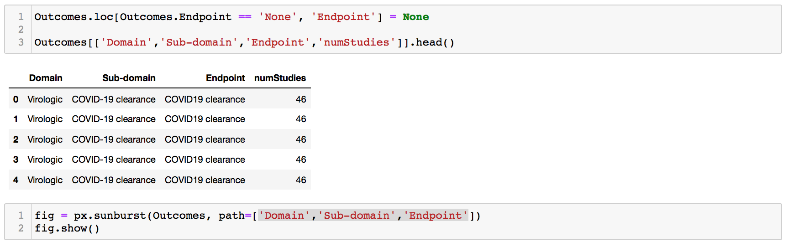

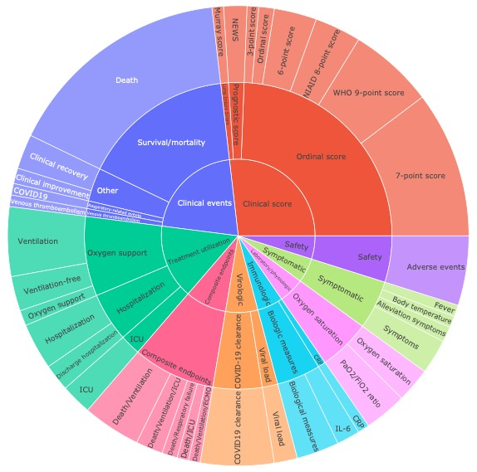

9. Heatmap for composite endpoint breakdown in R (Figure 7A)

head(Com)

## Death Ventilation  
## Discharge ICU/6-point score 0 0  
## Ventilation-free/WHO 9-point score 0 1  
## Discharge hospitalization/Ordinal score 0 0  
## Discharge hospitalization/7-point score (n=2) 0 0  
## Discharge hospitalization/Alleviation symptoms 0 0  
## Discharge hospitalization/Ventilation-free 0 1  
## Hospitalization ICU  
## Discharge ICU/6-point score 0 1  
## Ventilation-free/WHO 9-point score 0 0  
## Discharge hospitalization/Ordinal score 0 0  
## Discharge hospitalization/7-point score (n=2) 0 0  
## Discharge hospitalization/Alleviation symptoms 0 0  
## Discharge hospitalization/Ventilation-free 0 0  
## Discharge hospitalization ECMO  
## Discharge ICU/6-point score 0 0  
## Ventilation-free/WHO 9-point score 0 0  
## Discharge hospitalization/Ordinal score 2 0  
## Discharge hospitalization/7-point score (n=2) 2 0  
## Discharge hospitalization/Alleviation symptoms 1 0  
## Discharge hospitalization/Ventilation-free 1 0  
## Ventilation-free  
## Discharge ICU/6-point score 0  
## Ventilation-free/WHO 9-point score 1  
## Discharge hospitalization/Ordinal score 0  
## Discharge hospitalization/7-point score (n=2) 0  
## Discharge hospitalization/Alleviation symptoms 0  
## Discharge hospitalization/Ventilation-free 1  
## Alleviation symptoms Intubation  
## Discharge ICU/6-point score 0 0  
## Ventilation-free/WHO 9-point score 0 0  
## Discharge hospitalization/Ordinal score 0 0  
## Discharge hospitalization/7-point score (n=2) 0 0  
## Discharge hospitalization/Alleviation symptoms 1 0  
## Discharge hospitalization/Ventilation-free 0 0  
## 7-point score Organ dysfunction  
## Discharge ICU/6-point score 0 0  
## Ventilation-free/WHO 9-point score 0 0  
## Discharge hospitalization/Ordinal score 0 0  
## Discharge hospitalization/7-point score (n=2) 2 0  
## Discharge hospitalization/Alleviation symptoms 0 0  
## Discharge hospitalization/Ventilation-free 0 0  
## Arterial thromboembolism MI  
## Discharge ICU/6-point score 0 0  
## Ventilation-free/WHO 9-point score 0 0  
## Discharge hospitalization/Ordinal score 0 0  
## Discharge hospitalization/7-point score (n=2) 0 0  
## Discharge hospitalization/Alleviation symptoms 0 0  
## Discharge hospitalization/Ventilation-free 0 0  
## Ordinal score Oxygen support  
## Discharge ICU/6-point score 0 0  
## Ventilation-free/WHO 9-point score 0 0  
## Discharge hospitalization/Ordinal score 2 0  
## Discharge hospitalization/7-point score (n=2) 0 0  
## Discharge hospitalization/Alleviation symptoms 0 0  
## Discharge hospitalization/Ventilation-free 0 0  
## Oxygen-free Shock  
## Discharge ICU/6-point score 0 0  
## Ventilation-free/WHO 9-point score 0 0  
## Discharge hospitalization/Ordinal score 0 0  
## Discharge hospitalization/7-point score (n=2) 0 0  
## Discharge hospitalization/Alleviation symptoms 0 0  
## Discharge hospitalization/Ventilation-free 0 0  
## Venous thrombosis  
## Discharge ICU/6-point score 0  
## Ventilation-free/WHO 9-point score 0  
## Discharge hospitalization/Ordinal score 0  
## Discharge hospitalization/7-point score (n=2) 0  
## Discharge hospitalization/Alleviation symptoms 0  
## Discharge hospitalization/Ventilation-free 0  
## Additional treatment ARDS  
## Discharge ICU/6-point score 0 0  
## Ventilation-free/WHO 9-point score 0 0  
## Discharge hospitalization/Ordinal score 0 0  
## Discharge hospitalization/7-point score (n=2) 0 0  
## Discharge hospitalization/Alleviation symptoms 0 0  
## Discharge hospitalization/Ventilation-free 0 0  
## Arterial thrombosis  
## Discharge ICU/6-point score 0  
## Ventilation-free/WHO 9-point score 0  
## Discharge hospitalization/Ordinal score 0  
## Discharge hospitalization/7-point score (n=2) 0  
## Discharge hospitalization/Alleviation symptoms 0  
## Discharge hospitalization/Ventilation-free 0  
## Cardiac arrest  
## Discharge ICU/6-point score 0  
## Ventilation-free/WHO 9-point score 0  
## Discharge hospitalization/Ordinal score 0  
## Discharge hospitalization/7-point score (n=2) 0  
## Discharge hospitalization/Alleviation symptoms 0  
## Discharge hospitalization/Ventilation-free 0  
## Cardiovascular organ support  
## Discharge ICU/6-point score 0  
## Ventilation-free/WHO 9-point score 0  
## Discharge hospitalization/Ordinal score 0  
## Discharge hospitalization/7-point score (n=2) 0  
## Discharge hospitalization/Alleviation symptoms 0  
## Discharge hospitalization/Ventilation-free 0  
## Discharge ICU  
## Discharge ICU/6-point score 1  
## Ventilation-free/WHO 9-point score 0  
## Discharge hospitalization/Ordinal score 0  
## Discharge hospitalization/7-point score (n=2) 0  
## Discharge hospitalization/Alleviation symptoms 0  
## Discharge hospitalization/Ventilation-free 0  
## Intravascular coagulation  
## Discharge ICU/6-point score 0  
## Ventilation-free/WHO 9-point score 0  
## Discharge hospitalization/Ordinal score 0  
## Discharge hospitalization/7-point score (n=2) 0  
## Discharge hospitalization/Alleviation symptoms 0  
## Discharge hospitalization/Ventilation-free 0  
## Non-hemorrhagic stroke  
## Discharge ICU/6-point score 0  
## Ventilation-free/WHO 9-point score 0  
## Discharge hospitalization/Ordinal score 0  
## Discharge hospitalization/7-point score (n=2) 0  
## Discharge hospitalization/Alleviation symptoms 0  
## Discharge hospitalization/Ventilation-free 0  
## 6-point score WHO 9-point score  
## Discharge ICU/6-point score 1 0  
## Ventilation-free/WHO 9-point score 0 1  
## Discharge hospitalization/Ordinal score 0 0  
## Discharge hospitalization/7-point score (n=2) 0 0  
## Discharge hospitalization/Alleviation symptoms 0 0  
## Discharge hospitalization/Ventilation-free 0 0  
## Pulmonary embolism Renal failure  
## Discharge ICU/6-point score 0 0  
## Ventilation-free/WHO 9-point score 0 0  
## Discharge hospitalization/Ordinal score 0 0  
## Discharge hospitalization/7-point score (n=2) 0 0  
## Discharge hospitalization/Alleviation symptoms 0 0  
## Discharge hospitalization/Ventilation-free 0 0  
## Respiratory failure SOFA Stroke  
## Discharge ICU/6-point score 0 0 0  
## Ventilation-free/WHO 9-point score 0 0 0  
## Discharge hospitalization/Ordinal score 0 0 0  
## Discharge hospitalization/7-point score (n=2) 0 0 0  
## Discharge hospitalization/Alleviation symptoms 0 0 0  
## Discharge hospitalization/Ventilation-free 0 0 0  
## Venous thromboembolism  
## Discharge ICU/6-point score 0  
## Ventilation-free/WHO 9-point score 0  
## Discharge hospitalization/Ordinal score 0  
## Discharge hospitalization/7-point score (n=2) 0  
## Discharge hospitalization/Alleviation symptoms 0  
## Discharge hospitalization/Ventilation-free 0  
## Clinical improvement  
## Discharge ICU/6-point score 0  
## Ventilation-free/WHO 9-point score 0  
## Discharge hospitalization/Ordinal score 0  
## Discharge hospitalization/7-point score (n=2) 0  
## Discharge hospitalization/Alleviation symptoms 0  
## Discharge hospitalization/Ventilation-free 0  
## Rescue medication  
## Discharge ICU/6-point score 0  
## Ventilation-free/WHO 9-point score 0  
## Discharge hospitalization/Ordinal score 0  
## Discharge hospitalization/7-point score (n=2) 0  
## Discharge hospitalization/Alleviation symptoms 0  
## Discharge hospitalization/Ventilation-free 0

heatmap.2(Com,  
 cexRow=1, #ylab size  
 cexCol=1,  
 density.info="none", # turns off density plot inside color legend  
 trace="none", # turns off trace lines inside the heat map  
 margins =c(12,10), # widens margins around plot  
 lwid = c(0.2,4.5,2.8),  
 lmat = rbind(c(0,3,0),c(2,1,0),c(0,4,0)),  
 lhei=c(0.5,3.5,0.5),  
 col=c("gray95","#FC9272","#FB6A4A", "#EF3B2C", "#CB181D", "#A50F15","#67000D"),   
 breaks=c(0,0.1,1,2,3,4,7,15),   
 dendrogram="none", # only draw a row dendrogram  
 Rowv=NA,  
 Colv="NA")   
dev.off()



10. Lasagna plot in R (eFigure 2A)

head(longer_actual)

## # A tibble: 6 x 5  
## NCTId StudyType2_simple OverallStatus dates value  
## <chr> <chr> <chr> <date> <fct>  
## 1 NCT04244591 Intervention Completed 2020-01-01 0   
## 2 NCT04244591 Intervention Completed 2020-01-02 0   
## 3 NCT04244591 Intervention Completed 2020-01-03 0   
## 4 NCT04244591 Intervention Completed 2020-01-04 0   
## 5 NCT04244591 Intervention Completed 2020-01-05 0   
## 6 NCT04244591 Intervention Completed 2020-01-06 0

## by overall status  
lasagna_status = ggplot(longer_actual, mapping = aes(x = dates, y = NCTId , fill = value)) +  
 geom_tile() + xlab("Year") +   
 facet_grid(OverallStatus~., scales = "free", labeller = as_labeller(statuslabel))+  
 scale_fill_manual(values = c("grey","#fc4e2a","#800026","white"),labels=c("Before registration", "Registration--start","Started","Completed")) +  
 theme(axis.text.y = element_blank(), axis.ticks.y = element_blank(), axis.title.y = element_blank(),  
 panel.background = element_blank(),  
 plot.background = element_blank(),  
 strip.text.y = element_text(angle = 0), legend.title = element_blank()) + geom_vline(aes(xintercept=as.Date("2022-01-09", format="%Y-%m-%d")), colour="#6495ED")

